

Auto Account

User’s Guide

Copyright © 2007 by Health Quest, Inc

Basic Accounting Functions Overview 4
Monthly Schedule of Duties 4
Starting Up 4
Menus and Buttons 5
Receiving and Posting Payments 6
Handling Funds 6
Posting Payments 6
Posting Payments to Resident Ledger 6
Editing Incorrect Payments on the Resident Ledger 8
Posting Miscellaneous Collections 9
Editing Incorrect Miscellaneous Collections 10
Printing the Deposit Ticket and Making the Deposit 10
Recording the Deposit 11
Checking Deposit Balances 11
Checking Delinquent Accounts 12
Invoicing 14
Overview of Resident Data 14
Billing Procedure 14
Billing for Additional Charges 15
Billing For “Other” Charges 16
Printing Invoices 17
Printing Mailing Labels 18
Billing Individual Residents 18
Making Adjustments 19
Adjusting an Individual’s Resident Ledger 19
Adjustment Types 20
Editing Incorrect Adjustments 21
Month-End Reports 22
Updating the Rent Roll 22
Updating Charity 22
Group Reports Print 23
A/ R Reconciliation Detail 24
Accounts Receivable Reconciliation 25
Adjustment Report 26
Booking By Resident and Unit 26
Cash Back Report 27
Charity Booking By Unit 27
Deposit Balances 29
Deposits By Cost Center 29
Delinquency Report 30
Ledger Check Report 30
Other Income Report 31
Other Income Detail Report 32
Other Income Check Report 32
Prepaid Adjustment Check Report 33
Prepaid Previous Detail 34
Prepaids Report 35
Prepaid Reconciliation 36
Rent Roll Balance Sheet 37
Rent Roll Balances Check 37
Resident Billing Comparison 38
Resident Rent Roll 39
Resident Subsidy Tracking 40
Resident Subsidy Amounts 40
Resident Subsidy Balances Reports 41
Resident Subsidy Ledgers 42
Security Deposit Balances 43
Security Deposit Check 44
Security Deposit Ledger 44
Services Balance Sheet 46
Services Potential Check 47
CSM Rent Roll Report List 48
Locking the Accounting Period 49
Archiving Old Accounting Records 49
Closing-Out Past Accounting Records 49
Reviewing Historical Accounting Records 50
Main Menu 51
Change Password 51
Accounting Menu 53
Resident Ledger 54
Miscellaneous Collections 55
Edit Miscellaneous Collections 56
Balance Sheet Options 56
Accounting Check Options 57
Deposit Ticket 58
Confirmed Deposit 58
Invoice Options 59
Group Reports Print 60
Historical Ledger 61
Exit to Main Menu 61
Rent Roll Update 61
Updating Charity 62
Monthly Billing 62
Accounting Period Lock 63
Admin Menu 64
Add User 64
Delete User 65
Clear Password 65
Room Plan 66
Accounting Database Options 67
Accounting Descriptions 67
Account Close-Out 68
Table of Exhibits 69

Basic Accounting Functions Overview

The accounting function at CSM properties consists mainly of recording and depositing cash receipts, preparing monthly invoices, and preparing related month-end reports. With the implementation of the computerized system, these functions have been automated to a great degree. This manual describes the basics of the monthly accounting functions, and how these functions are performed using the accounting software.

The CSM computer system was designed using a database management program. This program is very user-friendly, and is designed specifically to be used with Microsoft Windows. The Accounting Module is part of the larger CSM computer program, which includes a Marketing Module. The Marketing Module may need to be accessed on occasion to get information on leases. The Marketing Manual provides directions on how to access information in the marketing module.

Monthly Schedule of Duties

The following is an outline of the accounting duties, which must be performed on a regular monthly basis:

Beginning of Month: Monthly charges for the current month are due by the 1st of that month. Each property’s lease(s) specifically details when late fees are applied and the appropriate late fee charge. The beginning of the month is usually the busiest in terms of receiving and posting payments, although this function is performed throughout the month.

Mid-Month: Invoices for the following month are generally prepared and mailed out by the 20th.

End of Month: For the independent and assisted living facilities the monthly accounting period ends at 2:00 pm on the 25th. At nursing facilities, the accounting period ends at 2:00 pm on the last day of the month. At this time, all payments for that month should be recorded and deposited. There are several monthly reports, which must be generated at this time to be sent to CSM headquarters. Once the reports are generated correctly, the previous accounting period must be locked out.

Starting Up

All computers will be equipped with surge suppressors. The monitor and the CPU should be left in the "ON" position at all times; power should be turned on and off from the surge suppressor switch. The Turbo feature located on the CPU should always be activated; there is never a need to disengage it. If during your use there is a network failure, simply click the Ctrl, Alt, and Delete buttons simultaneously. If this fails to reboot the computer, press the Reset button on the CPU and initiate the sign-on procedure.

Users sign on by supplying the correct password and clicking "OK". Move the cursor on top of the ACCOUNTING icon and double-click. You will now need to supply your "NAME" and "PASSWORD" and then click "OK". Remember that your password is case sensitive; if your password is in uppercase letters, you must key it in that way.

When the hourglass appears, it is a sign that the computer is processing a series of instructions. Do not click the mouse or press any keys while the hourglass is running; the computer will remember these entries and attempt to execute them. The Main Menu will appear.

Menus and Buttons

There are three menus which all display the property's logo. The menus contain labeled buttons that enable you to open the forms you need. All the buttons in this program are simple to use: by moving the mouse, put the arrow over the button and click once. You can achieve the same result from the keyboard by simultaneously pressing the “Alt” button and the underlined letter on the desired button.

BUTTONS
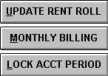

Receiving and Posting Payments

Handling Funds

When a payment is received, the check must immediately be stamped on the back with a restrictive endorsement. All properties have a stamp with the property name, the bank account number, and "For Deposit Only". This information should be stamped immediately on the back of each check, and all checks should be set aside to be posted.

It is very important to maintain security of all funds in your possession. For this reason, a bank deposit is required to be made daily, to minimize the amount of funds left in the facility overnight. Residents may only pay rent with a check or a money order. Cash is not acceptable.

Posting Payments

There are two ways to post payments on the computer. If a payment is related to a resident account, it must be posted through the Resident Ledger form. Payments received that are not related to resident accounts are posted through the Miscellaneous Collections form.

Posting Payments to Resident Ledger

To post payments to resident accounts, click the mouse on the Resident Ledger button on the Accounting Menu. Each resident has a separate record of billings, payments, and adjustments. This is a computerized version of a ledger card in a manual accounting system. To go to the record of the desired resident, click the arrow button on the "Select Resident" box at the top of the form. An alphabetical list of residents' names will appear. Go to the desired resident and click the mouse on their name. Alternatively, after the alphabetical list appears, you can type in the first letter of the desired resident's last name, and the names starting with that letter will appear. You can then click on the desired resident's name.
Exhibit 1: Resident Ledger
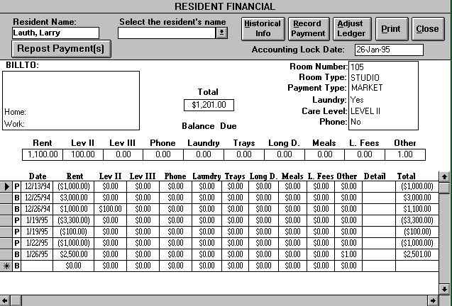

The resident ledger screen is used for a variety of purposes. This section deals only with the posting of payments. For a more detailed description of the resident ledger, please refer to the section II on Invoicing.

After you have pulled up the record of the desired resident, you are now ready to post the payment. Click the mouse on the RECORD PAYMENT button in the top right-hand corner of the form to open the Payment screen. The date field is set to today’s date by default but can be edited by the user. You cannot post payments to accounting periods before the lock date as displayed in the upper right hand side of the resident ledger. All billings, payments, and adjustments posted before the lock date cannot be edited by the user. Nor can any new billings, payments, or adjustments be created before date. Each month the bookkeeper “locks” the previous accounting period by setting the lock date through the Accounting Period Lock form. Next, select whether the payment is by cash or check, and then enter the amount of the payment and the appropriate deposit number. If payment is by check, enter the check number, the bank ID number, and the amount of cash back* given to the resident. Click on the UPDATE button, and the computer will automatically post the payment to the resident's ledger, as well as to the deposit ticket specified by the entered deposit number. Pressing the CANCEL button will return you to the resident ledger without posting or recording the payment.
Exhibit 2: Payment Form
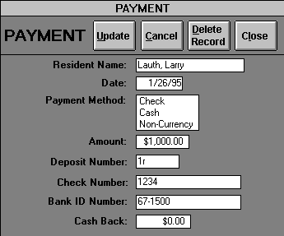

After the UPDATE button has been pressed, the resident's ledger will reappear with the payment posted. Payments will be designated by the letter “P” to the left of the date on the ledger. If you have another payment to post to that resident's ledger, you can press the RECORD PAYMENT button. If you need to post a payment to another resident's record, click the arrow button on the "Select Resident" box, and choose the resident whose ledger you wish to update.

*Note: For a few residents, it may be necessary to give them cash back from their rent payments. Some residents may sign over to you their Social Security and Virginia Auxiliary Grant checks. The combined total of these checks will probably be more than the amount of rent due. The difference is given back to the resident from your Petty Cash account (see Policies and Procedures Manual). The amount of cash returned is entered on the "Cash Back" line of the Payment screen. The total amount of the check will be printed on the deposit ticket, but the amount net of the cash back will be posted to the resident's account.

Editing Incorrect Payments on the Resident Ledger

If the payment information is entered incorrectly, you can edit it before pressing the UPDATE button on the Payment form. If you discover that the information was incorrect after the payment has been posted, you can still correct your error. Simply click on the “P” to the left of the Date on the ledger. This action will open the Payment form to the record corresponding to the payment you have selected. Once in the Payment form, you can make the appropriate changes. (Note: If you select a payment with a date less than the lock date, then you can only view but not edit the payment record.) The one field you cannot change is the amount. If you need to change an amount, make the change directly to the resident ledger in the appropriate ledger accounts. When you change the amount of a payment in the resident ledger, the corresponding Payment form record’s amount is automatically updated.

If you have posted a payment by mistake, you can simply delete the erroneous payment in one of two ways. First, you can click on the “P” to open the Payment form to the appropriate payment record. Next, simply press the DELETE RECORD button, which will delete both the Payment form record and the corresponding payment record in the resident ledger. A second option would be to select the record selector* of the appropriate payment record in the resident ledger and press the delete key on your keyboard. This action will achieve the same result as the previous option.

*A record selector is the small rectangular, gray box on the far left of each ledger record. When a particular ledger record(s) is selected this box turns a dark gray. When a ledger record is being edited, a pencil appears inside the record selector.

Posting Miscellaneous Collections

Payments that are received from residents are always posted to the Resident Ledger cards. Payments received from other sources are posted through the "Miscellaneous Collections" screen. You may receive payments from various sources not related to a resident, such as the guest room(s), sale of meal tickets to staff and guests, monthly rent payment from the beauty salon operator, coin operated laundry machine commissions, etc.

Exhibit 3: Miscellaneous Collections
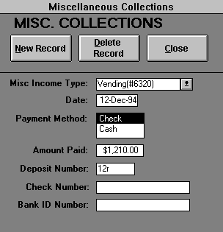

To post a miscellaneous payment, press the MISC. COLLECTIONS button on the Accounting Menu. The Miscellaneous Collections form will open to a new record. To choose the income type, press the arrow button on the "Misc. Income Type" box. A list of income types will appear. Press the down arrow button until you see the income type you wish to select. If you do not see the desired income type, you can create it by selecting "Other". Selecting “Other” opens the Miscellaneous Income Types form, where you can type in the desired income type. When you close this screen by clicking the CLOSE button, you will go back to the Miscellaneous Collections screen. Pull up the income type list again, and the income type that you just added will appear on the list. Click the mouse button on that income type, and it will be selected.

Once you have selected the desired income type, select the payment type (cash or check); enter the amount and the deposit number. If the payment is by check, enter the check number, and the bank ID number. If this is the only miscellaneous collection item you are posting, press the CLOSE button to return to the Accounting Menu. If you have other items to post, press the NEW RECORD button, and the screen will clear so that you can enter a new payment. If you have entered a Miscellaneous Collections record in error, press the DELETE RECORD button to delete the erroneous record.

Editing Incorrect Miscellaneous Collections

If you enter the miscellaneous collection information incorrectly, you can edit it if you have not already gone to a new record or closed the Miscellaneous Collections form. If you discover that the information was incorrect after one or both these events have occurred, you can still correct your error. First, click the EDIT MISC. COLLECTIONS button on the Accounting Menu to open the Edit Miscellaneous Collections form. Next, you must choose which miscellaneous collection record you wish to edit. To search for the misc. payment by deposit number, press the arrow button on the "Select payment record by deposit" box. To search for the misc. payment by income type, press the arrow button on the "Select payment record by income type" box. In either case, a list appears with the deposit number, income type, payment date, and amount. Select from the list the miscellaneous collection you wish to edit or delete. This action will open the Miscellaneous Collections form to the misc. payment record you selected from the list. You may then make your corrections, or delete the record entirely by clicking the DELETE RECORD button.

Printing the Deposit Ticket and Making the Deposit

After you are finished posting all the payments for the day, you are ready to print the deposit ticket. At the Accounting Menu, press the DEPOSIT TICKET button. A screen will appear asking you to enter the deposit number. Type in deposit number and press "enter" or select the deposit number from the list. The Deposit Ticket form will appear on the screen.

Exhibit 4: Deposit Ticket
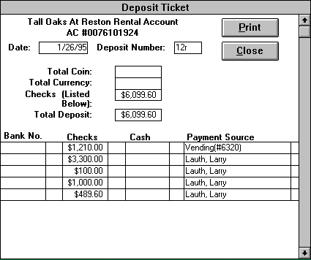

Listed beside each payment is the payment source. The payment source is the resident’s name for a resident ledger payment and the income type for a miscellaneous collection payment. Clicking on the payment source will open up the appropriate payment or miscellaneous collection record. The user can then edit these records if they are incorrect or delete them if they are extraneous. You cannot change the amount of a resident payment; this can only be changed through the resident ledger. Furthermore, payments made in locked, past accounting periods can be viewed, but cannot be edited.

Run an adding machine tape of your checks to make sure that the total checks listed on the deposit ticket are correct. Count your total coins and currency, and enter the amounts in the appropriate boxes. The total coin, currency, and checks should add up to the total deposit listed on the deposit ticket. If this correct, press the PRINT button to print the deposit ticket.

You must also fill out a bank deposit ticket. Instead of listing the checks individually on the ticket, however, just write "see attached" and enter the total checks. Make photocopies of both deposit slips and all the checks. You can then take the deposit to the bank. The teller will stamp the computer deposit ticket and give it back to you. They will also give you a handwritten deposit confirmation. When you get back to the office, make photocopies of these two items, and file along with the photocopies of the checks. The original computer deposit slip and deposit confirmation should be stapled together, along with the adding machine tape. These are sent to CSM headquarters in Roanoke. You must also call CSM to tell them the amount of the deposit so that they can log it into the property’s checkbook.

Recording the Deposit

The final step in making the bank deposit is recording the confirmed amount of the deposit in the computer. This ensures that the deposit posted to the computer equals the deposit amount received by the bank. At the Accounting Menu, press the RECORD DEPOSIT button to open the Confirmed Deposit form. If you wish to record a new deposit, enter the deposit number in the "Deposit Number" box. Next, enter the deposit amount and date. To enter another deposit, click the NEW RECORD button. Click on the CLOSE button to exit and return to the accounting menu.

Exhibit 5: Confirmed Deposit
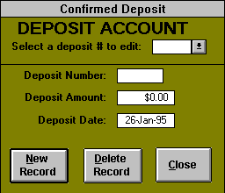

If you wish to edit a previously entered deposit, press the arrow button beside the box labeled "Select a Deposit #", to get a list of the previously entered deposits. Choose a deposit, and the data for that deposit will appear. Edit the items you wish to change. If you wish to delete the entire record (for example, it was entered twice by mistake), press the Delete record button. After you are finished, press the Close button to return to the Accounting Menu.

Checking Deposit Balances

On a daily basis, you need to check to be sure that the deposits posted to the computer equal the deposits taken to the bank by viewing the Deposit Balances form. This form displays a listing of all deposits for the month. The "Entry Deposit" column lists the deposits as entered through the Resident Ledger and the Miscellaneous Collections forms. The "Confirmed Deposit" column lists the deposits confirmed by the bank, as entered through the Confirmed Deposit form. The Deposit Balances form also gives a total of the deposits made for the month.

Exhibit 6: Deposit Balances
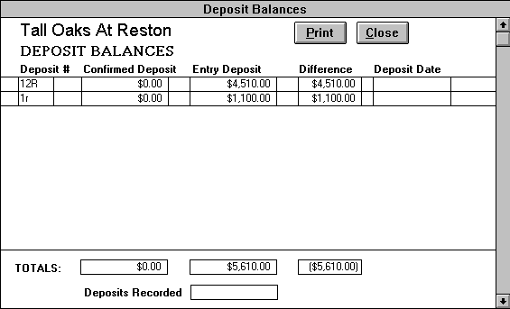

Checking Delinquent Accounts

On the day when late charges will start to be applied, you must check on the Delinquency Report to see which accounts are delinquent so that you can contact the resident or family member regarding payment of the rent. The form lists in alphabetical order all resident accounts that have not been paid as of today's date. When you click on the line of a particular resident, that resident's contact party name and telephone number will appear in the upper right portion of the screen. This will enable you to call that person to check on when the bill will be paid. This report is to be printed and given to the Administrator four days after the late charge date. The Administrator will then attempt to collect from the responsible party. Finally, a copy of the final report will be printed out and sent with the rent roll at the end of each monthly accounting period.
Exhibit 7: Delinquency Report
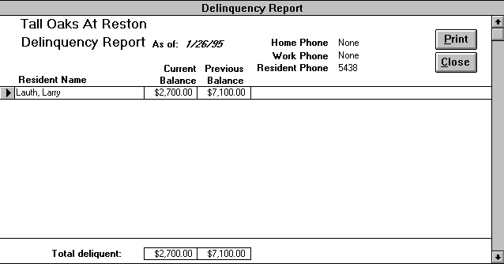

Invoicing

At mid-month, the invoices are prepared for the following month's charges. This process usually takes several days, depending on the number of residents in the facility, and the complexity of the billing system. It has been automated to a great degree, but the nature of it is such that it can never be fully automated. For this reason, a thorough knowledge of your property's resident population, and the type of charges that are regularly billed, are very important. Also, good communication with the Marketing and Admissions Departments is important to be ensure that new and discharged residents are billed appropriately.

Overview of Resident Data

When a new resident moves into the facility, the Marketing or Admissions Department will enter the appropriate billing information into the computer. Therefore, the resident's name, room number, billing party name and address, and levels of service should already be in the system. If this information is correctly entered, and is in the system prior to the date that you perform your invoicing procedures, the resident will automatically be billed for the correct amount of contract rent and services.

At the end of the month, you need to verify that what the Marketing Department entered in the computer corresponds to the amounts you billed the residents for rent and contract services. In the Accounting Menu, press the ACCOUNTING CHECK button to view the Accounting Check Options form. A list box appears with several forms to choose from. Click on "Resident Billing Comparison" to open the Resident Billing Comparison form. This form displays all the residents whose billing amounts for rent and contract services differs from the information the Marketing Department have entered in the residents’ leases.

Billing Procedure

The automated billing function will bill each resident for rent and contract services for the month. Any additional items to be billed to a resident must be added through the Resident Ledger.

Before running the automated billing function, it is a good idea to make sure that all the resident information is correct. This saves editing time later. For example, if a resident's billing party has changed, this information should be in the computer prior to running the billing function so that the correct information will be printed on the invoice and mailing label. Or, if a resident is changing service levels or room types, the correct information should be in the system so that the correct amount will be billed.

Once you are reasonably sure that the resident information in the computer is correct, you are ready to run the billing function. At the Accounting Menu, press the Monthly Billing button. A warning message will be displayed reminding you that this button should be pressed only once a month. Pressing this button more than once per month will result in duplicate billings. If you have pressed the button by mistake, press the CANCEL button to return to the Accounting Menu. If you wish to bill the residents, press the OK button. The program will bill each resident for the contractual rent and services.

Billing for Additional Charges

If there are any additional charges to be billed, they must be added through the Resident Ledger form. At the Accounting Menu, press the Resident Ledger button to open this form. Next, select the record of the desired resident.

Exhibit 8: Resident Ledger
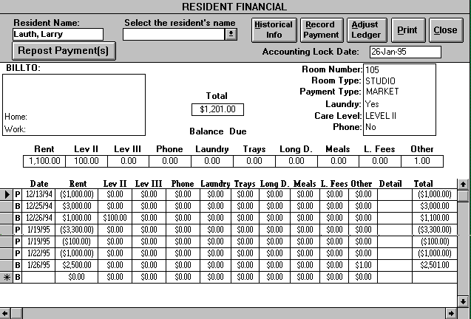

If you have already billed for the month (See: Billing Procedure), you will observe that the computer has automatically added the rent and contract service charges to the resident's account. The billing date is ALWAYS the first day of your accounting cycle. So, for example, if your accounting period runs from the 26th of one month through the 25th of the following month, your billing date would be the 26th of the first month. There should only be one billing per resident per accounting period.

You should also observe that there are several categories of charges for non-contractual items. These categories have been custom-tailored to your property based on the most commonly occurring charges. Some properties bill regularly for long distance charges, tray deliveries, and late fees. For those less frequently occurring items, there is a category label "Other"(See: Billing for “Other” Charges). To add charges to a resident's bill, go to the line for the current month's billing, and click the mouse on the appropriate category. Type in the amount of the charge and press "Enter". The resident's bill will be updated to reflect the additional charge. All billings are positive numbers while all payments are negative numbers.

Repeat this procedure for all residents for whom noncontractual charges must be billed. After you have finished, you are ready to print the invoices and mailing labels.

Billing For “Other” Charges

For those less frequently occurring items that do not have their own category on Resident Ledger form, there is a category on the ledger labeled "Other.” When you enter a bill amount on the appropriate bill line in the "Other" category, the Other Income Options form will open. In order for other charges to be categorized properly on the month-end reports, the other income type must be entered. Click on the New button, which displays the Other Income form with the resident's name and the billing date. Press the down arrow on the right side of the "Other Income Type" box. A list of other income types will appear. This is the same list that appears when you are posting miscellaneous collections. Select the desired income type. If you do not see the appropriate income type, you can create it by selecting "Other". Selecting “Other” opens the Miscellaneous Income Types form, where you can type in the desired income type. When you close this screen by clicking the CLOSE button, you will go back to the Other Income screen. Pull up the income type list again, and the income type that you just added will appear on the list. Click the mouse button on that income type to select it.

Exhibit 9: Other Income Options
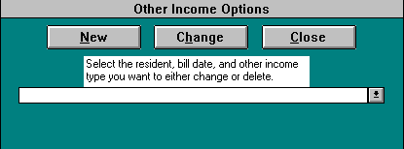

Enter the amount of the charge. If there are additional Other charges, press the NEW button. Follow the procedure described above to enter the next income type. When you are finished, press the CLOSE button. The total of all Other charges entered must equal the total amount in the Other column on the resident ledger. If it is not, a warning message will be displayed and you will be returned to the Other Income Options form. If necessary, you can click on the CHANGE button to select the erroneous Other Income record to edit or delete. Once the other income record(s) and the ledger balance, you will be returned to the resident ledger screen. In the detail column, enter a description of the Other charges. The descriptions entered in the detail column will appear beside the charge for Other services on the invoice.

Exhibit 10: Other Income
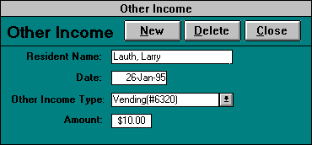

It is most efficient to bill for the Other charges at the same time as you bill each resident for the other noncontractual charges.

Printing Invoices

Invoices can be printed by entire group, individual, or range of residents. The individual printing option is useful when a new resident has moved in and you need to print an invoice for that resident only. When the regular monthly invoicing procedures are performed, you usually will want to utilize the ‘All’ print option. The range print option is useful for printing a group of residents without having to print out invoices for all residents.

At the Accounting Menu, press the Invoice button to open the Invoice Options form. The default bill date is the bill date of the current accounting period. If you wish to print an invoice(s) for a different month, simply change the bill date to the bill date of the desired month.

Exhibit 11: Invoice Options
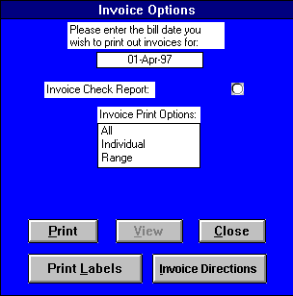

The Invoice Check Report is a useful report for error-checking the resident invoices prior to printing. To select this report, click on the circle. To print this report only, press the PRINT button without choosing anything in the “Invoice Print Options” box. It is generally a good idea to print this report before printing all the resident invoices. The report can be reviewed to determined if there are any errors, and the errors can be corrected before going through the invoice printing process.

Exhibit 12: Invoice Check Report
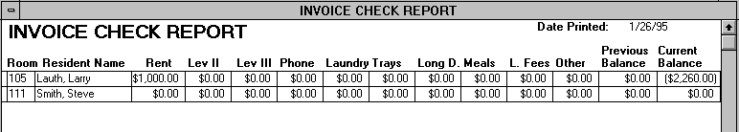

After the Invoice Check Report has been reviewed and any corrections made, the resident invoices can be printed. On the Invoice Options form, enter in the desired bill date if it’s different from the default bill date. Under "Invoice Print Options", select "All" and click the PRINT button to print all the invoices. Clicking the “Range” option opens the ‘From’ and ‘To’ resident selection boxes. Pressing the Print button will print the resident invoices within the alphabetical resident range selected.

You can also print or view an individual’s invoice. In “Invoice Print Options” box, select "Individual". A list of resident names will appear. Choose the desired resident, and then press the Print button to print the invoice or VIEW to view it.

Click on CLOSE when you wish to exit the Invoice Options form and return to the Accounting Menu.

Printing Mailing Labels

To print invoice mailing labels, press the PRINT LABELS button on the Invoice Options form. Select the ‘All’ option to print all the current resident labels or the ‘Range’ option to print a selected range of resident invoice labels. The labels will print automatically with the name and address of the billable party for each resident.

Print mailing labels on regular paper, transferring the addresses to mailing labels through your copier machine. The labels needed to print the invoice mailing labels are Avery 5160, 1" X 2 5/8", 3 X 10, 30 labels per sheet.

Billing Individual Residents

On occasion, you will be asked to provide an invoice for an individual resident. This normally happens when someone must be billed outside of the normal billing cycle, such as when a new resident moves in. The Monthly Billing function is not used in this instance, because it bills all the residents. In this case, go to the Resident Ledger for the resident you wish to bill. At the Accounting Menu, press the RESIDENT LEDGER button to open this form. Select the name of the desired resident. Click the mouse button in the "Date" column in a blank record at the bottom of the ledger and enter in the appropriate bill date. Observe that the letter “B” is to the left of the date on your bill line in the ledger. The “B” signifies that this line is a bill. Remember, even though this billing is outside the normal, automatic billing cycle, the bill date is ALWAYS the first day of your accounting cycle. Also, remember that all your bill amounts must be positive. Never enter a negative amount on a bill ledger line. Type in the amount you wish to bill the resident in the various categories. For instance, if they are moving in on the 1st of the month, you would type in the amount of a full month's rent in the rent column. If they are moving in at mid-month, you would type in the amount of a half-month's rent. If you are unsure of the proper amounts to bill, the Marketing/Admissions Department should be able to provide guidance.

After entering the desired billing amounts, click the mouse on a blank section of the screen to total the amounts, and confirm that they have been entered correctly. Once you are satisfied with the amounts as entered, the invoice can be printed as detailed in the Printing Invoices section.

Making Adjustments

Adjustments allow the user to record in the current accounting period changes to the Resident Ledger that need to be made to past accounting periods. Adjustments are necessary because at the end of each month, after all the rent roll reports have been completed, the bookkeeper “locks” the previous accounting period by setting the lock date through the Accounting Period Lock form. All billings, payments, and adjustments before this date cannot be edited by the user. Nor can any new billings, payments, or adjustments be created with a date before the lock date. Since, the user cannot edit locked, past accounting periods, adjustments provide the tool to make corrections to past periods. For example, you post a check to rent for $1,000(payments are always negative) near the end of an accounting period. You run all your rent roll reports and lock out the accounting period. At the beginning of the new accounting period, you are informed that the check bounced. Since you cannot delete out the now locked out payment, you need to make an adjustment to rent for $1,000 to clear out the bounced check and correct your ledger.

Adjusting an Individual’s Resident Ledger

To make an adjustment to a resident account, click the mouse on the RESIDENT LEDGER button on the Accounting Menu to open the Resident Ledger form. Then choose on the desired resident's name from the “Select the resident’s name:” box.

After you have pulled up the record of the desired resident, you are now ready to make an adjustment. Click the mouse on the ADJUST LEDGER button in the top right-hand corner of the form to open the Adjustment screen. The date field is set to today’s date by default but can be edited by the user. You cannot post adjustments to accounting periods before the lock date as displayed in the upper right hand side of the resident ledger. First, select the appropriate adjustment type. Next, enter in the correct amounts in each of the adjustment accounts. These accounts correspond to the accounts on the Resident Ledger. The amounts you enter should adjust the problem in the previous accounting period(s). For example, you discover that a resident was overbilled $100 in rent the previous month. You open the adjustment form, and select on the overbilled adjustment type. Next, you enter in -$100 in the rent field on the adjustment form to offset the $100 overbilling. Click on the UPDATE button, and the computer will automatically post the adjustment to the resident's ledger. Pressing the CANCEL button will return you to the resident ledger without posting or recording the adjustment.
Exhibit 13: Adjustment Form
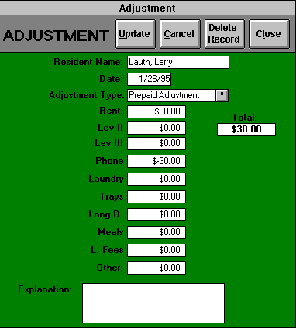

After the UPDATE button has been pressed, the resident's ledger will reappear with the adjustment posted. Adjustments will be designated by the letter “A” to the left of the date on the ledger. If you need to post a payment to another resident's record, click the arrow button on the "Select Resident" box, and choose the resident whose ledger you wish to update.

Note: You cannot make more than one adjustment per resident ledger per accounting period. If multiple adjustments are necessary, you must combine the adjustments into one adjustment. Select the adjustment type for the largest of the adjustments.

Adjustment Types

Meal Credit - this is an adjustment to reduce rent billed in a previous month. Meal credits are only available to those facilities that include meals in their rent rates. The amount in rent should be a negative number.

NSF Adjustment - this adjustment type cancels out a bounced check in a previous period. Your adjustment total should be a positive number to offset the bounced check. If you discover a bounced check in the current accounting period, instead of making an adjustment, you redeposit the check at the bank. If the check bounces again after a second redeposit, simply delete the payment from the resident ledger and immediately request another check from the billable party.

Overbilled - if a resident is overbilled, he has been billed too much. Your adjustment total should be a negative number to offset the overbilling.

Underbilled - if a resident is underbilled, he has been billed too little. Your total should be a positive number to augment the previous underbilling.

Prepaid Adjustment - money is shifted between income accounts to adjust to billings made after the initial prepayment. Your total should be zero as the income accounts balance one another out. This type of adjustment is often identified by the Ledger Check Report.

Prepaid Refund - this adjustment is granted after a resident leaves a facility but has a prepaid balance. Your total should be a positive number to offset the prepaid balance. Only use this adjustment after a check has been processed for the resident.

Write Off - this adjustment occurs when CSM decides to write off a certain portion of a resident's bill. Your total should be a negative number to offset the billing amount being written off.

Sometimes you have to make multiple adjustments to a resident’s ledger in one accounting period. Since you are allowed only one adjustment per resident ledger per accounting period, you must combine the adjustments into one adjustment. Select the adjustment type for the largest of the adjustments. For example, you might have underbilled a resident $50 in rent, but overbilled him $5 for laundry service. Therefore, your adjustment type would be underbilled with an adjustment total of $45. Note: a prepaid adjustment can never be the type selected in a combination adjustment, since its adjustment total is always zero.

Editing Incorrect Adjustments

If an adjustment is entered incorrectly, you can edit it before pressing the UPDATE button on the Adjustment form. If you discover that the information was incorrect after the adjustment has been posted, you can still correct your error. Simply click on the “A” to the left of the Date on the ledger. This action will open the Adjustment form to the record corresponding to the adjustment you have selected. Once in the Adjustment form, you can make the appropriate changes. (Note: If you select an adjustment with a date before the lock date, then you can only view but not edit the record.) When you change the account amount(s) in the Adjustment form, the corresponding resident ledger account amounts are automatically updated and vice versa.

If you have posted an adjustment by mistake, you can simply delete the erroneous adjustment in one of two ways. First, you can click on the “A” to open the Adjustment form to the appropriate record. Next, simply press the DELETE RECORD button, which will delete both the Adjustment form record and the corresponding adjustment record in the resident ledger. A second option would be to select the record selector of the appropriate adjustment record in the resident ledger and press the delete key on your keyboard. This action will achieve the same result as the previous option.

Month-End Reports

At the end of each monthly accounting period, reports must be generated and sent to CSM headquarters. These reports are used by CSM's accounting department to record income and cash receipts for your property for the month. The accounting program also contains check reports to which help to identify errors that may have been made when posting the payments, adjustments, and bills. Once the check reports have been reviewed and the errors corrected, the rent roll reports can be printed and sent to CSM. The easiest and most efficient way to print these reports is to utilize the Group Reports Print to print multiple reports at a time.

Updating the Rent Roll

Before printing the month-end reports, the computer must update the Rent Roll for all transactions that have occurred during the month. At the Accounting Menu, press the Update Rent Roll button to open the Rent Roll Update form. The user can then choose the appropriate month and the year to run the rent roll reports for. The program will not allow the user to update a particular rent roll if the previous accounting period has not been locked out through the Accounting Record Lock form. Once the desired month and year are entered, click the RENT ROLL button. The computer will then automatically review all transactions for the specified month and year and update the Rent Roll reports accordingly. This procedure takes a minute or so. The Rent Roll can be updated at anytime, and as many times as you like. Remember, however, that if you post any transactions for the current accounting period after updating the Rent Roll, the Rent Roll reports will not reflect the new transactions until the rent roll is updated again.

Note: Rent rolls can also be updated through the Group Reports Print form.

Updating Charity

Before printing the month-end charity reports, Booking by Resident and Unit and Charity Booking By Unit, the computer must update the charity reports for all transactions that have occurred during the month. At the Accounting Menu press the Update CHARITY button to automatically review all transactions for the current rent roll month and year (specified through the rent roll update form) and update the charity reports accordingly. This procedure takes a minute or so. The charity reports can be updated at anytime, and as many times as you like. Remember, however, that if you post any transactions for the current accounting period after updating the charity, the charity reports will not reflect the new transactions until the charity is updated again.

Note: Charity reports can also be updated through the Group Reports Print form.

Group Reports Print

At the Accounting Menu, press the GROUP REPORT PRINT button to open the Group Report Print form. This form contains all the rent roll accounting reports. To select a report for printing mark the print box to the right of the desired form name. Unmark this box to unselect a report for printing. When you click on the PRINT button all the marked reports will print. If the ‘Update Rent Roll’ and the ‘Update Charity’ boxes are marked, then the rent roll and the charity reports will be updated before the selected reports print. Press the CLOSE button to return to the Accounting Menu.

Exhibit 14: Group Reports Print
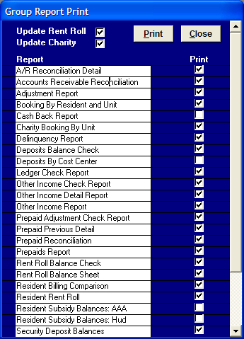

A/ R Reconciliation Detail

This report is a detailed resident version of the Accounts Receivable Reconciliation report. In order to be sure that the entries CSM will make from your monthly reports will result in the correct Accounts Receivable balances on their books, you can view the Accounts Receivable Reconciliation report. From the Accounting Menu press the ACCOUNTING CHECK button to view the Accounting Check Options form. In the list box, click on the "A/R Reconciliation Detail.” This report starts with the beginning balances in the Accounts Receivable accounts (Delinquent Rent, Delinquent Services, and Delinquent Other) for each resident, and shows the adjustments for the month that CSM will make using your Rent Roll Balance Sheet and Services Balance Sheet. The total of the three ending balances should equal the total delinquent of the current balance on the Delinquency Report. To print the form, click on the Print button.

Exhibit 15: A/R Reconciliation Detail
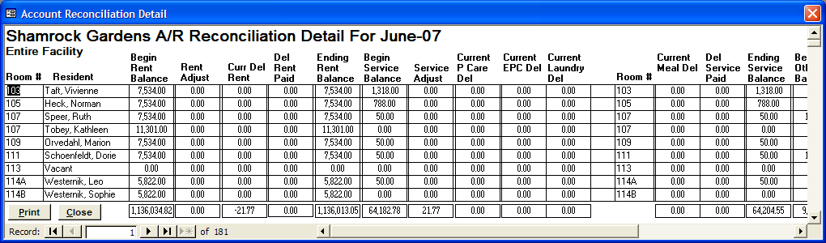

Accounts Receivable Reconciliation

CSM’s accounting department uses the monthly reports to update the general ledger and prepare the financial statements. In order to be sure that the entries CSM will make from your monthly reports will result in the correct Accounts Receivable balances on their books, you can view the Accounts Receivable Reconciliation report. From the Accounting Menu press the ACCOUNTING CHECK button to view the Accounting Check Options form. In the list box, click on "Accounts Receivable Reconciliation”. This report starts with the beginning balances in the Accounts Receivable accounts (Delinquent Rent, Delinquent Services, and Delinquent Other), and makes the adjustments for the month that CSM will make using your Rent Roll Balance Sheet and Services Balance Sheet. The total of the three ending balances should equal the total delinquent of the current balance on the Delinquency Report. Make sure that each of the ending balance equals “Balance Check”. To print the form, click on the Print button.

Exhibit 16: Accounts Receivable Reconciliation
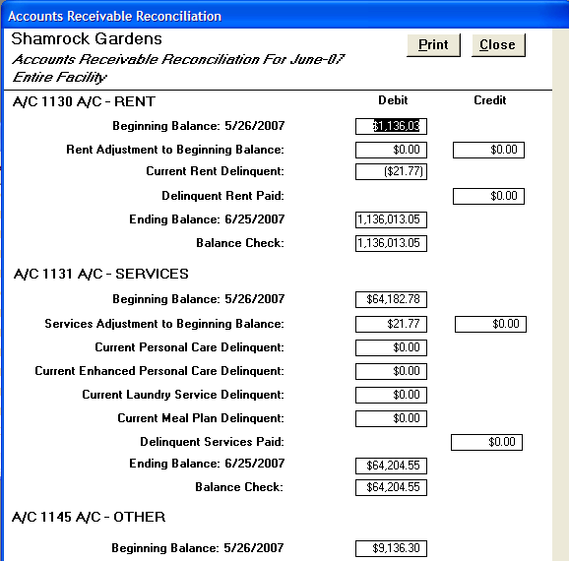

Adjustment Report

This report summarizes all the adjustments that have been posted during the current accounting period. The Adjustment Report lists the date, resident name, adjustment type, the adjustment amounts in each of the ledger accounts, and any explanation noted with each adjustment.

To open this report, go to the Accounting Menu and press the ACCOUNTING CHECK button to view the Accounting Check Options form. In the list box, click on "Adjustment Report”. Press the PRINT button to print the report and the CLOSE button to return to the Accounting Menu.

Exhibit 17: Adjustment Report
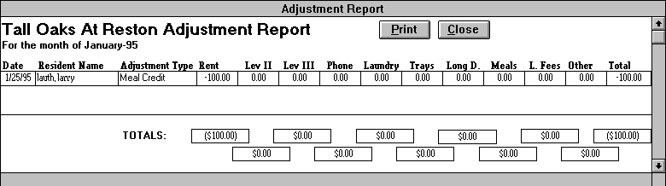

Booking By Resident and Unit

This read-only charity form details the amount of rent and level charity booked for the accounting month by resident and unit. Also, the Booking By Resident and Unit form tracks vacancy, reduced occupancy loss, rent and doubled occupancy billing amount, for each unit that each resident occupied during the month. This form also displays the number of days during the month that a particular resident was in each unit. You should review this form each month to check that you have the resident occupying the correct units for the correct number of days. Before viewing and/or printing this form, you must update the charity so this form will be reflective of the current month’s transactions. Also, since this form depends both on the accuracy of the marketing lease changes and the resident ledger billing amounts, it will not be accurate until the Resident Billing Comparison form is blank.

Exhibit 18: Booking By Resident and Unit
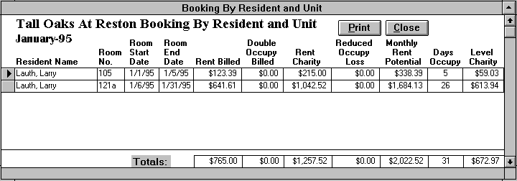

To open this form, on the Accounting Menu click on ACCOUNTING CHECK to open the Accounting Check Options form. In the list box, click on "Booking By Resident and Unit". Press the Print button to print the report. Click on the CLOSE button to return to the Accounting Menu.

Cash Back Report

The *Cash Back Report provides a list of those residents to whom cash was given for rent overpayments. Please refer to the note in the posting payments to the resident ledger section for a discussion of the "Cash Back" policy. To open this form, on the Accounting Menu click on BALANCE SHEETS to open the Balance Sheet Options form. In the list box, click on "Cash Back Report". A summary of residents who received cash back from rent overpayments will appear. Press the Print button to print the report.

Exhibit 19: Cash Back Report
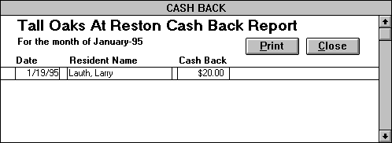

*Only print this report if there are residents during the accounting period that you have given cash back to.

Charity Booking By Unit

This read-only form details the amount of rent and level charity booked for the accounting month by unit. Also, the Charity Booking By Unit form tracks unit vacancy, reduced occupancy loss, rent and doubled occupancy billing amount, and the number of days during the month that each unit was occupied. Before viewing and/or printing this form, you must update the charity so this form will be reflective of the current month’s transactions. Also, since this form depends both on the accuracy of the marketing lease changes and the resident ledger billing amounts, it will not be accurate until the Resident Billing Comparison form is blank.

Exhibit 20: Charity Booking By Unit
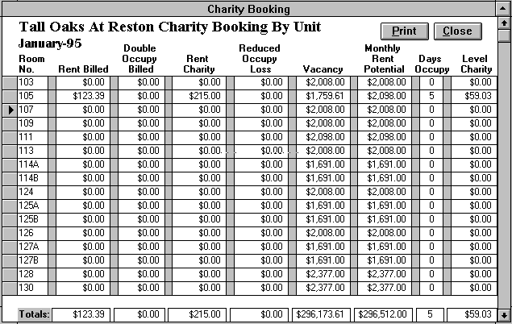

To open this form, on the Accounting Menu click on BALANCE SHEETS to open the Balance Sheet Options form. In the list box, click on "Charity Booking By Unit". Press the Print button to print the report. Click on the CLOSE button to return to the Accounting Menu.

Deposit Balances

This form displays a listing of all deposits for the month. The "Entry Deposit" column lists the deposits as entered through the Resident Ledger and the Miscellaneous Collections forms. The "Confirmed Deposit" column lists the deposits confirmed by the bank, as entered through the Confirmed Deposit form. The Deposit Balances form also gives a total of the deposits made for the month. If there is a deposit out of balance, pull up that deposit in the Deposit Ticket form. By comparing the deposit ticket form against your check copies and adding tape, you should be able to identify and correct your error.

Exhibit 21: Deposit Balances
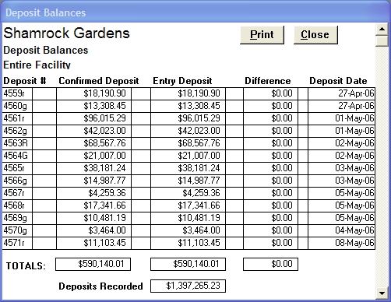

To open the Deposit Balances form, go to the Accounting Menu, press the ACCOUNTING CHECK button to view the Accounting Check Options form. At the list box, click "Deposits Balance Check".

Deposits By Cost Center

This print only report is for those properties that allocate costs and revenues to multiple cost centers. This report summarizes the deposits made to each cost center during the current rent roll period. To print the Deposits By Cost Center report go to the Accounting Menu, press the ACCOUNTING CHECK button to view the Balance Sheet Options form. At the list box, click "Deposits By Cost Center".

Delinquency Report

The form lists in alphabetical order all resident accounts that have not been paid as of the lesser of the current date or the end of the current rent roll month’s payment period. On the day when late charges will start to be applied, you check this form to see which accounts are delinquent so that you can contact the resident or family member regarding payment of the rent.

To view this form, first press the BALANCE SHEETS button on the Accounting Menu to open the Balance Sheet Options form. A list box appears with several forms to choose from. Click on "Delinquency Report" to open the selected form. When you click on the line of a particular resident, that resident's contact party name and telephone number will appear in the upper right portion of the screen. This will enable you to call that person to check on when the bill will be paid. This report is to be printed and given to the Administrator four days after the late charge date. The Administrator will then attempt to collect from the responsible party. Finally, a copy of the final report will be printed out and sent with the rent roll at the end of each monthly accounting period.

Ledger Check Report

Like the Rent Roll Balances Check form, the Ledger Check Report identifies residents whose resident ledgers are not in balance with the rent roll. In most cases, this is the result of a posting error where the user posts a payment and then later adjusts the bill without reposting the payment. The Ledger Check Report is much more detailed than the Rent Roll Balances Check form in that it checks all the individual ledger accounts and not just the totals. This report should be blank for your rent roll to be correct.

Exhibit 22: Ledger Check Report
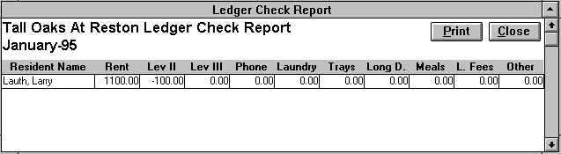

To open this report, go to the Accounting Menu and press the ACCOUNTING CHECK button to view the Accounting Check Options form. In the list box, click on "Ledger Check Report.” The report displays a list of the individual residents whose individual ledger accounts are out of balance with the rent roll. The amount in the ledger account reveals how much each ledger account is off from the rent roll. For example, this report displays a resident with $50 in the rent account and -$50 in the other account. For the resident’ ledger to be correct, the rental account must be reduced by $50 and -$50 added to the other account.

For the most part, these errors are simple to correct. First, go to the Accounting Menu and click on the RESIDENT LEDGER button to open the Resident Ledger form. Next, select the resident that is out of balance. Then click on the REPOST PAYMENT(S) button. This action will automatically repost all the payments for the current accounting period in the correct amounts and ledger categories. After you have reposted all the payments on the erroneous resident ledgers, update the rent roll and reopen the Ledger Check Report to determine if all the problems have been corrected leaving the report blank. If there are still resident ledgers in error, then the error lies in a past accounting period and you should consult the Prepaid Adjustment Check Report. After correcting all the errors identified in the Prepaid Adjustment Check Report, update the rent roll, and check to see if the Ledger Check Report is now blank and error free.

Other Income Report

This report summarizes all amounts billed in “other” account of the Resident Ledger form. On the Rent Roll Balance Sheet, the amounts billed to "other" on the resident ledger are summarized in one line item called "Resident Other". The Other Income Report provides a breakdown of the categories of other income included in this total. To open this form, on the Accounting Menu click on BALANCE SHEETS to open the Balance Sheet Options form. In the list box, click on "Other Income Report." To print the report, press the Print button.

Exhibit 23: Other Income Report
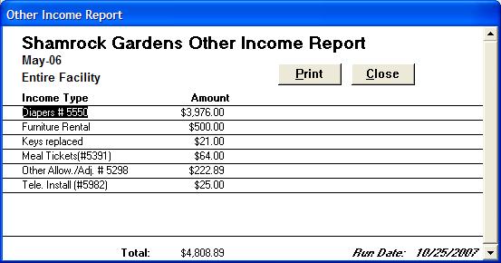

To verify that the amount entered in the Resident Ledger equals the amount entered in the Other Income form, open the Other Income Check Report.

Other Income Detail Report

This report is a detailed resident version of the “Other Income Report” by summarizing all amounts billed in other account of the Resident Ledger form by resident name and other income account. On the Rent Roll Balance Sheet, the amounts billed to "other" on the resident ledger are summarized in one line item called "Resident Other". To open this form, on the Accounting Menu click on BALANCE SHEETS to open the Balance Sheet Options form. In the list box, click on "Other Income Detail Report." To print the report, press the Print button.

Exhibit 24: Other Income Detail Report
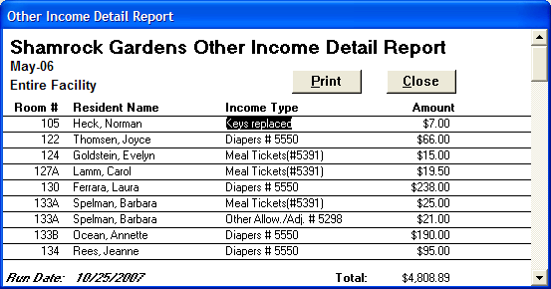

To verify that the amount entered in the Resident Ledger equals the amount entered in the Other Income Detail form, open the Other Income Check Report.

Other Income Check Report

This report identifies all residents whose amount billed to the “other” account in the Resident Ledger does not equal the amount entered in the Other Income form. The Other Income Report will not be correct until these amounts balance. Therefore after reviewing this list, you must correct these errors through the individual resident ledger. To correct the error, first reenter the correct amount in the “other” account on the appropriate billing line of the resident ledger. This action will cause the Other Income Options form to open. Next click on the CHANGE button if you need to edit or delete an Other Income record or the NEW button if you need to add one.
Exhibit 25: Other Income Check Report
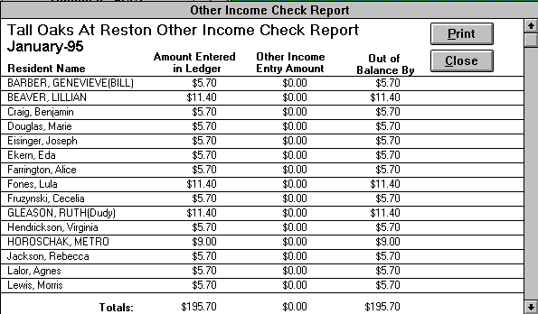

To open this form, on the Accounting Menu click on ACCOUNTING CHECK to open the Accounting Check Options form. In the list box, click on "Other Income Check Report". Press the Print button to print the report. Click on the CLOSE button to return to the Accounting Menu.

Prepaid Adjustment Check Report

Like the Ledger Check Report, the Prepaid Adjustment Check Report identifies residents whose resident ledgers are not in balance with the rent roll. This is usually the result of a posting or adjustment error made in a prior period. If the error is a posting error in the current period, using the REPOST PAYMENT button through the resident ledger will correct the problem. If there are still residents showing on the report after reposting each out of balance ledger, then the error lies in a past accounting period and must be corrected with an adjustment.

To correct this type of problem, first print out and then close the Prepaid Adjustment Check Report. Next, open the Resident Ledger form and select the appropriate resident’s ledger. Click on the ADJUST LEDGER button to open the Adjustment form. If the amounts for the resident ledger offset, then the type of adjustment needed in this case is a prepaid adjustment. The amounts displayed in the Prepaid Adjustment Check Report form should then be entered in the corresponding accounts in the Adjustment form. Remember the date entered for the adjustment must fall within the current rent roll’s payment period. Click on the UPDATE button, and the computer will automatically post the adjustment to the resident's ledger. After correcting all the identified errors, update the rent roll, and check to see if the report is now blank and error free. This report should be blank for your rent roll to be correct.

To open this report, go to the Accounting Menu and press the ACCOUNTING CHECK button to view the Accounting Check Options form. In the list box, click on "Prepaid Adjustment Check Report.” The report displays a list of the individual residents whose individual ledger accounts are out of balance with the rent roll. The amount in the ledger account usually reveals how much each ledger account is off from the rent roll. For example, this report displays a resident with $50 in the rent account and -$50 in the other account. For the resident’ ledger to be correct, the rental account must be reduced by $50 and -$50 added to the other account.

Exhibit 26: Prepaid Adjustment Check Report
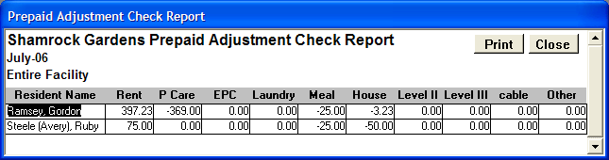

Prepaid Previous Detail

This report is a detail version of the prepaid previous totals section of the Services Balance Sheet. This report details each resident who had prepaid previous amount applied to a non rental account during the current rent roll month. To open this form, at the Accounting Menu press the ACCOUNTING CHECK button to view the Accounting Check Options form. In the list box, click on “Prepaid Previous Detail”. To print the form, click on the Print button.

Exhibit 27: Prepaid Previous Detail
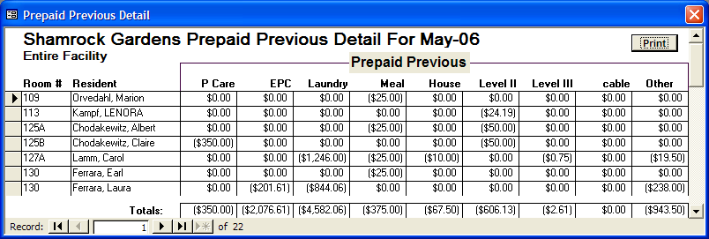

Prepaids Report

The form lists in alphabetical order all resident accounts that have a prepaid balance as of the lesser of the current date or the end of the current rent roll month’s payment period. You check this form to see which accounts are currently prepaid.

Exhibit 28: Prepaids Report
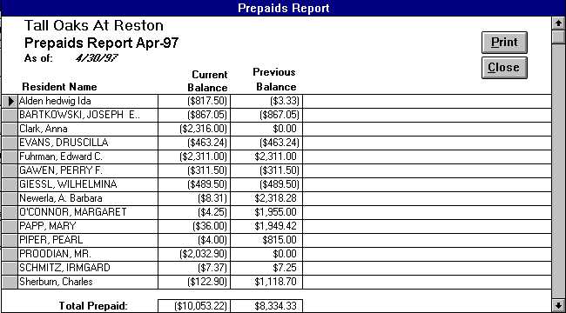

To view this form, first press the BALANCE SHEETS button on the Accounting Menu to open the Balance Sheet Options form. A list box appears with several forms to choose from. Click on "Prepaids Report" to open the selected form. Click on the Print button to print the form, and press CLOSE to exit the form.

Prepaid Reconciliation

The Prepaid Reconciliation form confirms the balance in the Prepaid Rent and Services account. The report is in the same format as the Accounts Receivable Reconciliation form described earlier. To open this form, at the Accounting Menu press the ACCOUNTING CHECK button to view the Accounting Check Options form. In the list box, click on “Prepaid Reconciliation”. Confirm that the ending balance equals “Balance Check”. To print the form, click on the Print button.

Exhibit 29: Prepaid Reconciliation
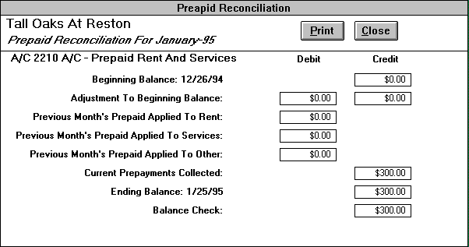

Rent Roll Balance Sheet

The function of the Rent Roll Balance Sheet is to summarize for CSM the total cash received for the month, and to provide a breakdown of the categories of income from which the cash receipts were derived. To view this form, first press the BALANCE SHEETS button on the Accounting Menu to open the Balance Sheet Options form. A list box appears with several forms to choose from. Click on "Rent Roll Balance Sheet" to open the Rent Roll Balance Sheet form. This form consists of two parts. The top part balances the rent to monthly gross rent potential. Monthly gross rent potential is the total amount of rent that could be collected if all rooms in the facility were filled, and all residents were paying the market rate. On the form, "Monthly Gross Potential" should equal the "Total" amount. The monthly gross potential only changes when the contract rents increase at the property’s annual rental increase.

Exhibit 30: Rent Roll Balance Sheet
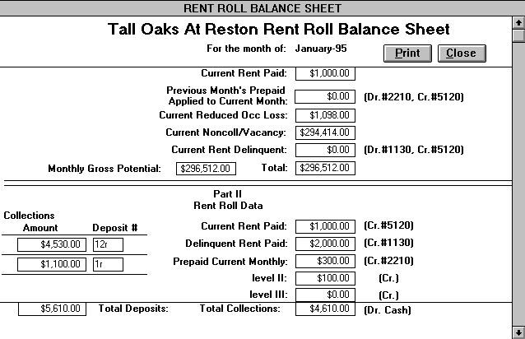

The bottom part of the Rent Roll Balance Sheet provides a breakdown of all the cash collected for the month, and compares it to the bank deposits made. The "Total Deposits" must equal the "Total Collections". If everything balances, press the Print button to print the report. Otherwise, check the Rent Roll Balances Check and Ledger Check Report forms to identify the error(s). Click the CLOSE button to return to the Accounting Menu.

Rent Roll Balances Check

If the Rent Roll Balance Sheet is out of balance, you must determine the reason and correct the problem. In most cases, there has been a posting error in a resident's ledger. In the Accounting Menu, press the ACCOUNTING CHECK button to view the Accounting Check Options form. A list box appears with several forms to choose from. Click on "Rent Roll Balances Check" to open the form with the same name. This form displays a list of the individual residents whose total payments recorded in the resident ledger do not equal the resident rent roll total. The difference will appear in the "Out of Balance" column. If the form is blank, then there are no residents out of balance.

Exhibit 31: Rent Roll Balance Check
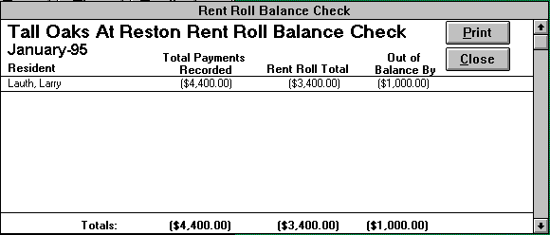

In most cases, the error occurs because amounts have not been posted in accordance with CSM's standard order of precedence. There, payments must be posted in the following order to be correct:

- Delinquent Rent
- Delinquent Services
- Delinquent Noncontractual Charges
- Contract Rent
- Contract Services
- Noncontractual Charges

These errors usually happen when an amount in a bill, payment, or adjustment has been edited manually. To rectify this error at the Accounting Menu, click on the RESIDENT LEDGER button to open the Resident Ledger form. Next, select the resident that is out of balance. Then click on the REPOST PAYMENT(S) button. This action will automatically repost all the payments for the current accounting period in the correct amounts and ledger categories. Once all the discrepancies have been found and corrected, you must update the rent roll again. You can then view the Rent Roll Balance Sheet and determine if the problem(s) has been corrected.

Resident Billing Comparison

The purpose of this form is to compare the billing information the marketing department has entered against the billing information in the Resident Ledger. Each month you have the computer automatically bill all the current residents. If a new resident moves into the facility after this automatic billing or a resident’s financial obligations change, the billing in the resident ledger will be incorrect. Therefore, the Resident Billing Comparison form identifies the difference between your contract rent and services ledger billing and the inputted marketing information. For each of the residents that are in error, check with the marketing department to verify what the correct billing for the resident should be. If the error lies in the Resident Ledger, edit the appropriate billing line and enter in the correct amounts in each of the ledger accounts. Then make sure to press the REPOST PAYMENT(S) button to ensure that your current period’s payments are posted to the appropriate accounts in the right amounts. If the error lies in the marketing billing information, the marketer must make the proper changes to the incorrect resident lease.

Exhibit 32: Resident Billing Comparison
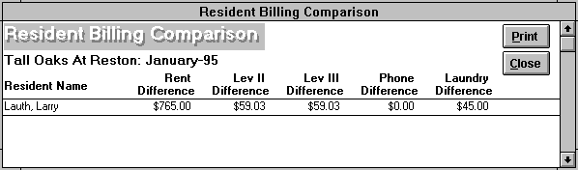

After correcting all the erroneous residents, update the rent roll again and recheck the Resident Billing Comparison form. If the form is blank, then there are no residents whose marketing billing information differs from the resident ledger billings. It is very important that this form is blank for until all the discrepancies between the marketing and accounting billing information have been rectified, the Charity Booking By Unit and the Booking By Resident and Unit forms will be incorrect.

To open this form, on the Accounting Menu click on ACCOUNTING CHECK to open the Accounting Check Options form. In the list box, click on "Resident Billing Comparison". Press the Print button to print the report. Click on the CLOSE button to return to the Accounting Menu.

Resident Rent Roll

The Resident Rent Roll is a detailed of analysis of every resident in the facility. It summarizes the charges for the month, and indicates if there is a delinquency, prepaid amount, or adjustment. To view this form, first press the BALANCE SHEETS button on the Accounting Menu to open the Balance Sheet Options form. A list box appears with several forms to choose from. Click on "Resident Rent Roll." The report can be viewed to confirm that it is correct. The totals should correspond to the amounts reported on the Rent Roll Balance Sheet and Services Balance Sheet. In particular, you should review the Previous Delinquent Rent, Previous Delinquent Services, and Previous Prepaid columns. These totals should equal the ending balances on last month's rent roll. Review the Current Delinquent Rent, Current Delinquent Services, and Current Prepaid amounts to confirm that they are correct. To print the report, press the PRINT button.

Exhibit 33: Resident Rent Roll
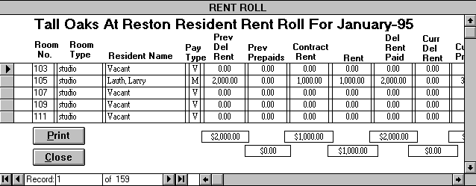

Resident Subsidy Tracking

The purpose of this form is to provide forms and reports that allow you to track any residents receiving subsidies from outside organizations. Specifically, this form allows you to open the following forms/reports through the Accounting Check Options form: Resident Subsidy Amounts, Resident Subsidy Ledgers, Resident Subsidy Balances: AAA, and Resident Subsidy Balances: HUD. Pressing the VIEW FORM button will open the specified report for viewing and/or printing. Clicking the CANCEL button will close this form and return the user to the Accounting Menu.

Exhibit 34: Resident Subsidy Tracking
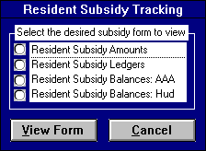

Resident Subsidy Amounts

This form allows you to enter each resident’s monthly subsidy and bill the resident’s subsidy ledgers. To open this form, first open the Accounting Check Options form and select ‘Resident Subsidy Tracking.’ After the Resident Subsidy Tracking form opens select ‘Resident Subsidy Tracking’ and click the VIEW FORM button.

To enter a resident’s monthly subsidy amount, select the appropriate name from the resident list on a new blank record. If your resident is not in the list, click the ALL button to expand the list to all residents. Next select one of the two subsidy types, HUD or AAA. Finally enter in the monthly subsidy amount. If a resident is discharged or no longer receives a subsidy, the resident must be deleted from this list. To delete a resident’s subsidy, first click on the gray record selector button to the left of the resident’s name. Then, press the Delete key on your keyboard.

Each month, you need to initiate the billing for the resident subsidy amounts. Simply, click the BILLING button and the Subsidy Billing form appears. Enter the appropriate billing date for the month for which you wish to bill. Then, pressing the SUBSIDY BILLING button creates a bill on each resident’s ledger on the specified billing date in the amount of his or her subsidy. Please only bill for your subsidies on a monthly basis.
Exhibit 35: Resident Subsidy Amounts
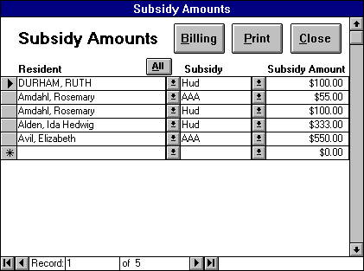

The PRINT button will print out the form, while the CLOSE button will close the form and return the user to Resident Subsidy Tracking.

Resident Subsidy Balances Reports

There are resident subsidy balance reports for each of the two subsidy types: Resident Subsidy Balances: AAA and Resident Subsidy Balances: HUD. These subsidy balance reports contain the subsidy balances for each resident for the current rent roll month. Each report contains the following fields: resident name, room #, subsidy type, beginning balance, billing amount, payment amount, ending balance, and balance check. If any resident’s balance check field is not zero, then there is an error in the resident’s ledger , which you need to correct.

Exhibit 36: Resident Subsidy Balances Reports
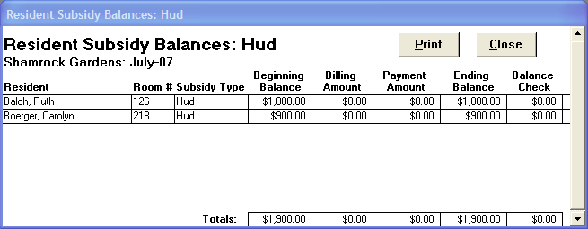

To open either of these reports, first open the Accounting Check Options form and select ‘Resident Subsidy Tracking.’ After the Resident Subsidy Tracking form opens select the desired reports name and click the VIEW FORM button. The PRINT button will print out the report, while the CLOSE button will close the form and return the user to Resident Subsidy Tracking.

Resident Subsidy Ledgers

The Resident subsidy ledger form allows you to record each resident’s subsidy payments and billings. You only need to utilize this form for residents receiving subsidies from outside organizations. To open this form, first open the Accounting Check Options form and select ‘Resident Subsidy Tracking.’ After the Resident Subsidy Tracking form opens select ‘ and click the VIEW FORM button.

To find the record of the desired resident, click the arrow button on the "Select the Resident’s Name" box at the top of the form. An alphabetical list of current residents' names will appear. Go to the desired resident and click the mouse on their name to go to their ledger. To expand the list to include all residents, not just current ones, click the ALL button.

The ledger is comprised of bill and payment postings. To enter a posting, select either ‘Bill’ or ‘Payment’ from the account type list box. (Bills are usually automatically entered by using the Billing button in the Resident Subsidy Amounts form. Nevertheless, you can enter bills manually through this form.) Next record the date of the posting. Bills can only fall on a facility’s designated billing date. Next, choose the subsidy type from the designated list. Then enter the amount of the posting, a positive number for bills and a negative one for payments. If recording a payment, also enter the deposit and check numbers. The balance total field provides the selected resident’s current subsidy balance.

Exhibit 37: Resident Subsidy Ledger
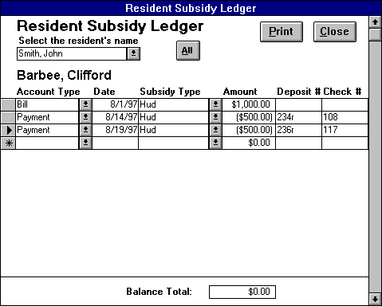

The PRINT button will print out a copy of the individual’s resident ledger, while the CLOSE button will close the form and return the user to the Accounting Menu.

Security Deposit Balances

This security deposit form list all residents who currently have a nonzero security deposit balance. This form includes the following fields: room #, resident name, security amount, lease start, and lease end date.

Exhibit 38: Security Deposit Balances
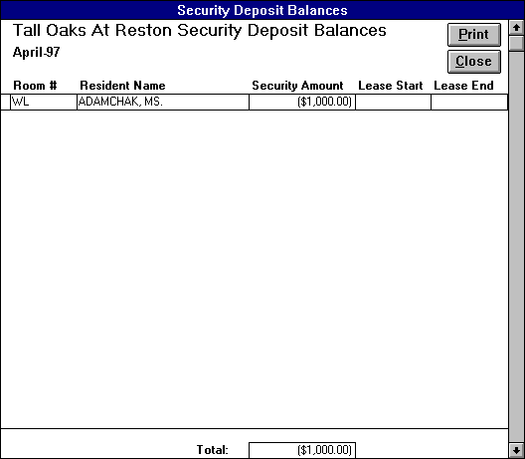

To view this form, first press the BALANCE SHEETS button on the Accounting Menu to open the Balance Sheet Options form. Click on "Security Deposit Balances" from the list box to open this form.

See Also
Security Deposit Ledger

Security Deposit Check

This check report list all the current residents for which there has been no security deposit payment recorded. Security Deposit Check lists the room #, resident’s name, lease start date, and lease end date.

Exhibit 39: Security Deposit Check
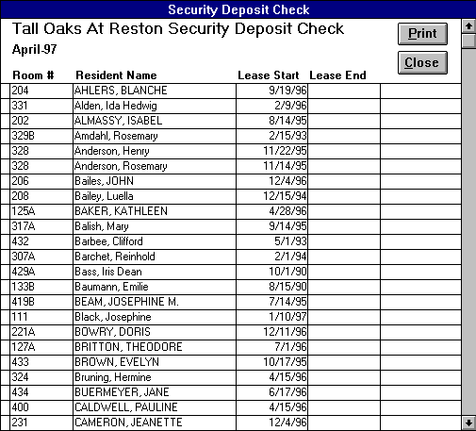

To open this form, on the Accounting Menu click on ACCOUNTING CHECK to open the Accounting Check Options form. In the list box, click on "Security Deposit Check". Press the Print button to print the report. Click on the CLOSE button to return to the Accounting Menu.

Security Deposit Ledger

This is form you utilize to record your security deposit transactions. This ledger details all the residents’ security deposit payments and refunds. The form lists resident’s name, date, transaction type, deposit #, check #, and amount. To view this form, first press the BALANCE SHEETS button on the Accounting Menu to open the Balance Sheet Options form. Click on "Security Deposit Ledger" from the list box to open this form. The form lists only those transactions occurring during the current rent roll payment period when initially opened. You may utilize the date range filter to view a longer time period.

To record a new security deposit transaction, press the ADD NEW button, which will go to a new record. Select from the resident name box the specific resident whose transaction you are recording. Next, enter the date of the transaction. The date field will default to the current date. Then, enter the requisite truncation type, either payment or refunded. If the transaction type is a payment, enter the deposit and check numbers and the amount should be a negative number. For refunded transactions, the amount should be a positive number. The refunded amount should balance out the initial security deposit payment.

Exhibit 40: Security Deposit Ledger
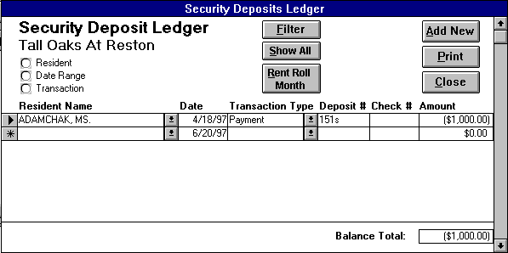

The filter options provide an efficient way to extract specific information from the resident security deposit records in this form. To initiate a filter, click on the option button() to the left of the desired filter selection to open a list of choices.(For example, choosing the resident option opens a list of all your entered residents). Next, select the desired item from the list. Then you can either choose another filter selection to refine your list even more, or process the records with the current selection by clicking the FILTER button. Pressing the FILTER button reduces the records to the defined filter option selections. Click the UNFILTER button to show all the service records again. The RENT ROLL MONTH button is a special type of filter. Pressing this button, refines the form to list only those transactions occurring during the current rent roll payment period. The following filters are located in the upper left-hand side of the form:

Resident - This list contains all potential residents entered through the Client Contact Information form in Market Leap.

Date Range - Any date range desired.

Transaction - Select one the desired transaction types: payment or refunded.

The PRINT button will print out a copy of the Security Deposit Ledger, while the CLOSE button will close the form and return the user to the Accounting Menu.

Services Balance Sheet

The Services Balance Sheet accounts for all contract services and other noncontractual charges billed during the month. While the Rent Roll Balance Sheet deals with cash collected, the Services Balance Sheet deals with amounts billed, regardless of whether they have been collected. The "Monthly Ancillary Services Potential" is the total of all contract services and other noncontractual charges that have been billed for the month. The rest of the report shows how much of the total was paid in the current month, how much is delinquent, and how much was paid by applying prepayments from the prior month.

Exhibit 41: Services Balance Sheet
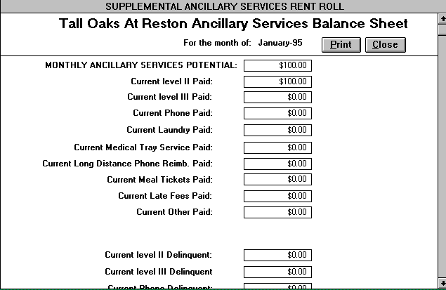

To open this report, go to the Accounting Menu and press the ACCOUNTING CHECK button to view the Accounting Check Options form. In the list box, click on "Services Balance Sheet”. The "Total" at the bottom of the form should equal the "Monthly Ancillary Services Potential". If the report balances, press the PRINT button to print. Otherwise, check the Services Potential Check and Ledger Check Report forms to identify the error(s). Click the CLOSE button to return to the Accounting Menu.

Services Potential Check

If the report is out of balance, it is probably due to a posting error in an individual resident's record. To open this report, go to the Accounting Menu and press the ACCOUNTING CHECK button to view the Accounting Check Options form. In the list box, click on "Services Potential Check”. This form displays a list of the individual residents whose service potential does not equal the resident rent roll amounts posted to contractual and noncontractual services. The difference will appear in the "Out of Balance" column. If the form is blank, then there are no residents out of balance.

Exhibit 42: Services Potential Check
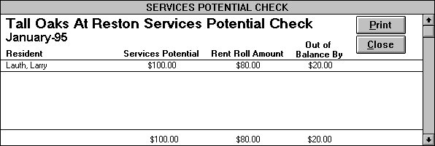

In most cases, the error(s) occurs because payments have not been posted in accordance with CSM's standard order of precedence. This can happen when an amount in a bill, payment, or adjustment has been edited manually. To rectify this error, at the Accounting Menu, click on the RESIDENT LEDGER button to open the Resident Ledger form. Next, select the resident that is out of balance. Then click on the REPOST PAYMENT(S) button. This action will automatically repost all the payments for the current accounting period in the correct amounts and ledger categories. Once all the discrepancies have been found and corrected, you must update the rent roll again. You can then view the Services Balance Sheet and determine if the problem(s) has been corrected.
Service Potential
The sum of all contract services and other noncontractual charges that have been billed to a resident for the month.

CSM Rent Roll Report List

Once all the reports have been verified as being correct and balanced, the following reports need to be sent to CSM at the end of the accounting period:

A/R Reconciliation Detail
Accounts Receivable Reconciliation
Adjustment Report
Booking By Resident and Unit
*Cash Back Report
Charity Booking By Unit
Delinquency Report
Deposits Balance Check
*Deposits By Cost Center
Ledger Check Report
Other Income Check Report
Other Income Detail Report
Other Income Report
Prepaid Adjustment Check Report
Prepaid Previous Detail
Prepaid Reconciliation
Prepaids Report
Rent Roll Balance Check
Rent Roll Balance Sheet
Resident Billing Comparison
Resident Rent Roll
*Resident Subsidy Balances: AAA
*Resident Subsidy Balances: HUD
Security Deposit Balances
Security Deposit Check
Security Deposit Ledger
Services Balance Sheet
Services Potential Check

*Only send these reports if your facility utilizes them.

Locking the Accounting Period

Once all the month-end reports balance and are sent to CSM, you must lock that month’s accounting period. Finalized accounting periods must be locked to prevent users from changing the accounting records and thereby changing the already completed rent roll reports. When you need to make a change to a past, locked accounting period, you make an adjustment in the current period. Furthermore, the accounting program will not allow you to update the current period’s rent roll until the previous period has been locked out*.

Exhibit 43: Accounting Period Lock
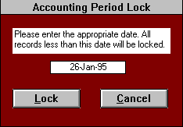

To lock the previous accounting period press the LOCK ACCT PERIOD button on the Accounting Menu. This action opens the Accounting Period Lock form. Next enter the appropriate lock date in the box provided. The lock date should equal the current period’s bill date. Finally, click on the LOCK button, which will lock the past accounting period and return you to the Accounting Menu.

*The program will allow you to post payments, adjustments, and bills in the current period even if you have not locked out the previous accounting period.

Archiving Old Accounting Records

After several months, a resident’s ledger becomes very full of payments, adjustments, and billings. Therefore, it is important to close out your accounting records periodically to archive old information to make way for new postings. The records should be closed-out on a yearly basis.

Closing-Out Past Accounting Records

Due to the importance of archiving past accounting records, only the local computer coordinator can perform an accounting close-out. When the time for a closeout approaches, the bookkeeper should remind the computer coordinator of this responsibility.

To closeout out past records, the computer coordinator clicks on the ACCOUNTING CLOSE-OUT button on the Admin Menu, which opens the Accounting Close-Out form. In this form, the user is required to enter a bill date. The closeout bill date must be at least one month before the lock date. After entering in the appropriate bill date, click on the INITIATE CLOSE-OUT button. All accounting records before the bill date then are removed from the Resident Ledger and stored in the Historical Ledger. The computer also automatically prints out a copy of each resident’s ledger for storage. In addition, the computer posts a bill dated one day before the closeout bill date to the individual resident ledgers with the appropriate balance forward amounts in each of the ledger accounts. These balance forward amounts can be prepaid, delinquent, or zero. When the closeout process is completed, the computer coordinator is returned to the Admin Menu.

Exhibit 44: Accounting Closeout
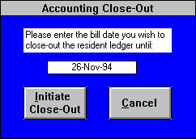

Reviewing Historical Accounting Records

Archiving accounting records does not delete past Resident Ledger records, it simply moves them to the Historical Ledger. The Historical Ledger is set up exactly like the Resident Ledger, except that you can only view the ledger, you cannot make any changes. Any changes you wish to make to past accounting periods can only be done through the Resident Ledger by posting an adjustment.

Exhibit 45: Historical Ledger
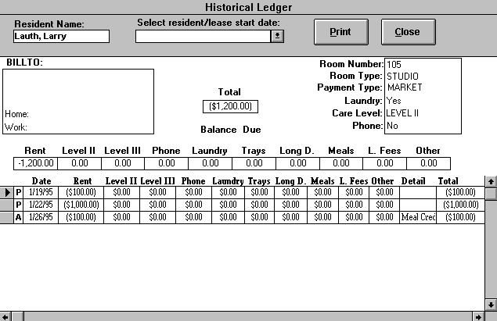

At the Accounting Menu, press the HISTORICAL LEDGER button to open the Historical Ledger form. Select the resident whose historical ledger you desire to view from the list box at the top of the form. Simply, click the PRINT button to print out the selected individual’s historical ledger. Clicking CLOSE will return you to the Accounting Menu.

Main Menu

On the "Main Menu", you can click the EXIT ACCOUNTING DATABASE button to exit the database. The Accounting Menu can be opened by clicking on the ACCOUNTING MENU button. All users may change their password using the Change Password button. Computer coordinators may also access the Admin Menu by pressing the ADMIN MENU button.

Exhibit 46: Main Menu
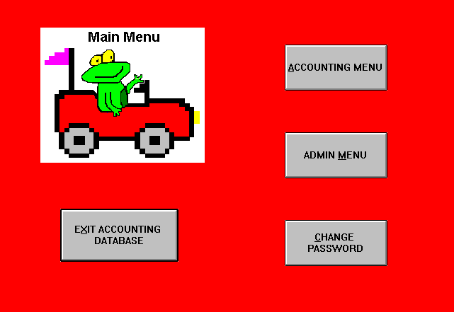

Change Password

Change Password allows the user to change his or her old user password to a new password for that user account. The user must enter the old password before the user can change the password. Text entered in the text boxes will be replaced with asterisks to conceal the password. The new password must also be verified. Press OK, and the new password will be asked on the next login. Press CANCEL if you decide not to change your password.
Exhibit 47: Change Password
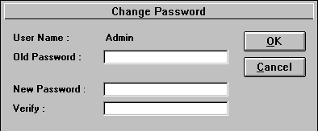

Passwords are best with at least five characters with letters and numbers, which is easy to remember for the user but hard to guess for outsiders. For example, use your grandmother's maiden name plus your father's birth date.
Use the Change Password feature as often as you like. If you feel someone has discovered your password, use the Change Password. The password is like a key. It is the user's responsibility in keeping that key safe. The password is used along with the user name for logging in to the database. Without the key, the user will not have access.

Accounting Menu

Exhibit 48: Accounting Menu
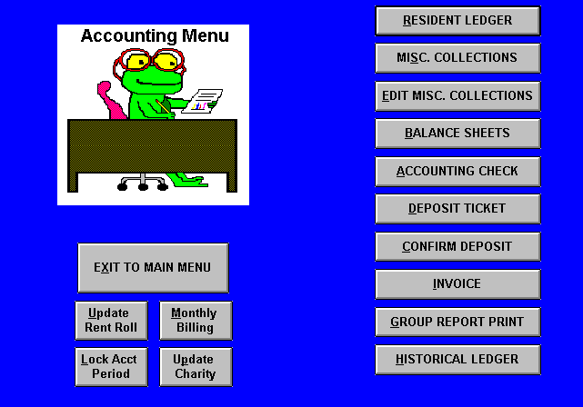

Resident Ledger

This is the primary form of the accounting program. Each resident has a separate record of payments, adjustments, and billings, which are sorted by date. The Resident Ledger is a computerized version of a ledger card in a manual accounting system.

Exhibit 49: Resident Ledger

To open this form, click the RESIDENT LEDGER button on the Accounting Menu. To find the record of the desired resident, click the arrow button on the "Select Resident" box at the top of the form. An alphabetical list of current residents' names will appear*. Go to the desired resident and click the mouse on their name. Alternatively, after the alphabetical list appears, you can type in the first letter of the desired resident's last name, and the names starting with that letter will appear. You can then click on the desired resident's name.

The top portion of the resident ledger lists billable party information and general lease information such as room number, room type, payment type, etc. In the center of this form is a listing of the individual current balances of each of the ledger accounts and the total current balance.

The bottom of the ledger is comprised of the postings. On the left of each posting is a letter, which identifies the type of positing. Payments will be designated by the letter “P”, adjustments by an “A”, and bills by a “B”. To post a payment to the resident ledger, click the mouse on the RECORD PAYMENT button. Utilize the REPOST PAYMENT(S) button to repost the current period’s payments. Pressing the ADJUST LEDGER button allows the user to make an adjustment to the ledger. To enter a bill, the user enters the appropriate amounts directly to the ledger. All of these postings have amounts entered in the designated ledger accounts, which are made up of rent, contract services, and noncontractual services. On the right side of the postings, the Total column equals the sum of the ledger accounts for a given posting, while the Balance column keeps a running total.

The PRINT button will print out a copy of the individual’s resident ledger, while the CLOSE button will close the form and return the user to the Accounting Menu.

See Also
Posting Payments to Resident Ledger
Editing Incorrect Payments on Resident Ledger
Billing for Additional Charges
Billing for “Other” Charges
Adjusting an Individual’s Resident Ledger
Editing Incorrect Adjustments

*Clicking the HISTORICAL INFO button, expands the “Select Resident” box to include past residents as well as current ones.

Miscellaneous Collections

The purpose of this form is to post payments received from sources other than the residents. At your facility, you will receive payments from various sources not related to a resident, such as the guest room(s), sale of meal tickets to staff and guests, monthly rent payment from the beauty salon operator, coin operated laundry machine commissions, etc. All of these types of payments, should be posted through the Miscellaneous Collections form.

Exhibit 50: Miscellaneous Collections

To open this form, click the MISC. COLLECTIONS button on the Accounting Menu.

See Also
Posting Miscellaneous Collections

Edit Miscellaneous Collections

This form allows the user to edit or delete incorrect postings to the Miscellaneous Collections form. To open this form, click the EDIT MISC. COLLECTIONS button on the Accounting Menu. Next, you select the miscellaneous collection record you wish to edit by either deposit or income type. By selecting the appropriate collection record, the Miscellaneous Collections form opens to the matching record, which can be edited or deleted.

See Also
Editing Incorrect Miscellaneous Collections

Balance Sheet Options

This form provides the list of the following primary month-end reports, which you can select to view and print. All of these reports must be printed out and sent to CSM at the end of each monthly accounting period. Before sending these reports to CSM, be sure to review all the check reports listed on the Accounting Check Options form. To open this form, press the BALANCE SHEETS button on the Accounting Menu. Click on CANCEL if you do not wish to open a rent roll report.

Exhibit 51: Balance Sheet Options
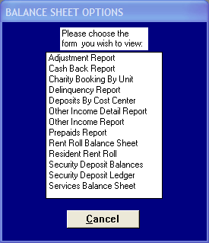

Accounting Check Options

This form provides the following list of the reports that identify errors that occur in your month-end rent roll reports listed in the Balance Sheet Options form. Utilize these reports to correct your payments, adjustments, and billings accordingly. Before sending any rent roll reports to CSM, be sure to review these accounting check reports. Except for the Rent Bill Comparison form, you do not have to send these reports to CSM. To open this form, press the ACCOUNTING CHECK button on the Accounting Menu. Click on CANCEL if you do not wish to open an accounting check report.

Exhibit 52: Accounting Check Options
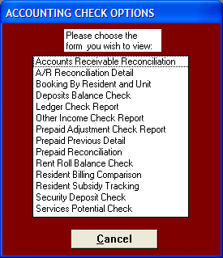

Deposit Ticket

This form is a listing of all the resident and miscellaneous payments posted to the selected deposit number. Listed beside each payment is the payment source. The payment source is the resident’s name for a resident ledger payment and the income type for a miscellaneous collection payment. Clicking on the payment source will open up the appropriate payment or miscellaneous collection record. The user can then edit these records if they are incorrect or delete them if they are extraneous. You cannot change the amount of a resident payment, this can only be changed through the resident ledger. Furthermore, payments made in locked, past accounting periods can be viewed, but cannot be edited.

Exhibit 53: Deposit Ticket

Enter the Deposit Ticket form through the Accounting Menu by pressing the DEPOSIT TICKET button. A screen will appear asking you to enter the deposit number. Type in deposit number and press "enter" or select the deposit number from the list. The selected Deposit Ticket will then appear on the screen.

See Also
Printing the Deposit Ticket and Making the Deposit

Confirmed Deposit

This form represents the final step in making a bank deposit. After a deposit has been completed, you must record the confirmed amount of the deposit in this form. This ensures that the deposit amounts posted to the residents’ ledgers and Miscellaneous Collections equals the deposit amount received by the bank since these two amounts are compared in the Deposit Balances form. At the Accounting Menu, press the RECORD DEPOSIT button to open the Confirmed Deposit form.
Exhibit 54: Confirmed Deposit

See Also
Recording the Deposit

Invoice Options

This form allows invoices to be printed by entire group, individual, or range of residents. There is also an option to simply view individual invoices. The individual printing option is useful when a new resident has moved in and you need to print an invoice for that resident only. When the regular monthly invoicing procedures are performed, however, you will want to print the invoices for all residents at one time. The range print option is useful for printing a group of residents without having to print out invoices for all residents.

Furthermore, the user can print out the Invoice Check Report. This is a useful report for error-checking the resident invoices prior to printing since it provides the same detail as the invoices in a more compact format.

Exhibit 55: Invoice Options
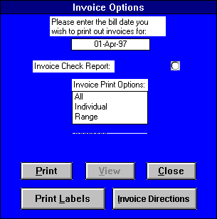

At the Accounting Menu, press the Invoice button to open the Invoice Options form. The default bill date is the bill date of the current accounting period. If you wish to print an invoice(s) for a different month, simply change the bill date to the bill date of the desired month.

See Also
Printing Invoices

Group Reports Print

At the Accounting Menu, press the GROUP REPORT PRINT button to open the Group Report Print form. This form contains all the rent roll accounting reports. To select a report for printing mark the print box to the right of the desired form name. Unmark this box to unselect a report for printing. When you click on the PRINT button all the marked reports will print. If the ‘Update Rent Roll’ and the ‘Update Charity’ boxes are marked, then the rent roll and the charity reports will be updated before the selected reports print. Press the CLOSE button to return to the Accounting Menu.

Exhibit 56: Group Reports Print

Historical Ledger

This form contains all the accounting records that that have been archived through the accounting closeout process. The Historical Ledger is set up exactly like the Resident Ledger, except that you can only view the ledger, you cannot make any changes.

Exhibit 57: Historical Ledger

At the Accounting Menu, press the HISTORICAL LEDGER button to open the Historical Ledger form. Select the resident whose historical ledger you desire to view from the list box at the top of the form. Simply, click the PRINT button to print out the selected individual’s historical ledger. Clicking CLOSE will return you to the Accounting Menu.

See Also
Reviewing Historical Accounting Records

Exit to Main Menu

Clicking on the EXIT TO MAIN MENU button on the Accounting Menu returns the user to the Main Menu.

Rent Roll Update

Before printing the month-end reports, the computer must update the Rent Roll for all transactions that have occurred during the month. At the Accounting Menu, press the Update Rent Roll button to open the Rent Roll Update form. Through this form, the user can then choose the appropriate month and the year to run the rent roll reports for. The Rent Roll can be updated at anytime, and as many times as you like. Remember, however, that if you post any transactions for the current accounting period after updating the Rent Roll, the Rent Roll reports will not reflect the new transactions until the rent roll is updated again.

Exhibit 58: Rent Roll Update
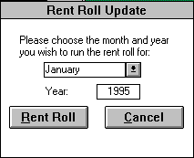

See Also
Updating the Rent Roll

Note: Rent rolls can also be updated through the Group Reports Print form.

Updating Charity

Before printing the month-end charity reports, Booking by Resident and Unit and Charity Booking By Unit, the computer must update the charity reports for all transactions that have occurred during the month. At the Accounting Menu press the Update CHARITY button to automatically review all transactions for the current rent roll month and year (specified through the rent roll update form) and update the charity reports accordingly. This procedure takes a minute or so. The charity reports can be updated at anytime, and as many times as you like. Remember, however, that if you post any transactions for the current accounting period after updating the charity, the charity reports will not reflect the new transactions until the charity is updated again.

Note: Charity reports can also be updated through the Group Reports Print form.

Monthly Billing

The automated billing function will bill each resident for rent and contract services for the month. At the Accounting Menu, press the Monthly Billing button. A warning message will be displayed reminding you that this button should be pressed only once a month. Pressing this button more than once per month will result in duplicate billings. If you have pressed the button by mistake, press the CANCEL button to return to the Accounting Menu. If you wish to bill the residents, press the OK button. The program will bill each resident for the contractual rent and services.

See Also
Billing Procedure

Accounting Period Lock

Each month the bookkeeper “locks” the previous accounting period by setting the lock date through the Accounting Period Lock form. The lock date should equal the current accounting period’s bill date. All billings, payments, and adjustments before this date cannot be edited by the user. Nor can any new billings, payments, or adjustments be created with a date before the lock date. This prevents changes from occurring to already finalized rent roll reports. Corrections to past periods are instead made through adjustments.

Exhibit 59: Accounting Period Lock

To open the Accounting Period Lock form, click on the LOCK ACCT PERIOD button at the Accounting Menu.

See Also
Locking the Accounting Period

Admin Menu

Exhibit 60: Admin Menu
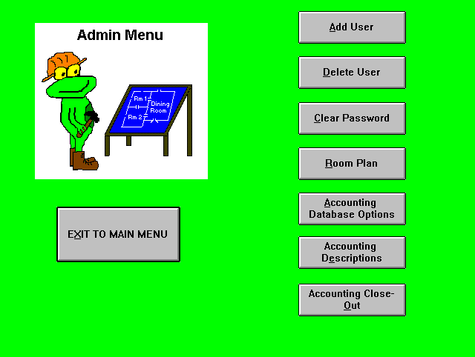

Add User

"Add User" allows the user that belong to the Administrator group or the Admins group to create a new user account for a new user. This user will be the computer coordinator. The computer coordinator must specify the new user name, his/her user group, personal id, and preferably a new password. The user account is an account identified by a user name and personal identifier (PID) that is created to allow access to the database. The user group identifies both the type of a user and the permissions granted that user. For example, users who belong to the Administrator's group are allowed to create new account and delete old ones, but users that belong to other groups are not allowed to add or delete accounts. The type of access you want to give to a user is defined by the group the user belongs in. The personal identifier is a case-sensitive alphanumeric string 4-20 characters long that the database uses to distinguish each user by. Passwords should be at lease five characters that have meaning to the new user but hard to guess for outsiders. After the new password is verified, press OK and the new account will be created. If you decide to cancel creating a new account, press Cancel. After a new account is created, the new user will be able to login to the database with the new user name and password.
Exhibit 61: Create New User
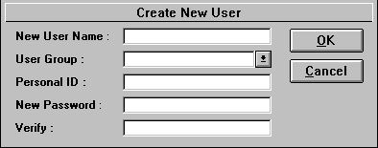

Delete User

"Delete User" allows the computer coordinator who belongs to the Administrator group or the Admins group to delete a user/user account. The coordinator must pick a user name from the list and press OK. If you decide not to delete the user, you can press Cancel. Once a user is deleted, you cannot retrieve it back. But you can create a new user with the last user name.

Exhibit 62: Delete User
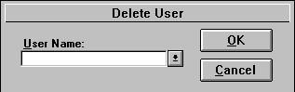

Clear Password

"Clear Password" allows the computer coordinator to clear a user password of a user. This is used in case the user forgot his or her password and wants to regain access to the database. The coordinator can then clear the password and have the user login to the database and immediately change password.

Exhibit 63: Clear Password
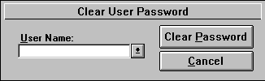
The coordinator must pick a user name from the list and press Clear Password. If you decide not to clear the password, you can press Cancel. Once the password is cleared, it is important that the user login to the database and change his or her password. By reducing the number of no-password accounts, the system can have better security.

Room Plan

The Room Plan form provides information to the database about the room plan of the facility. It is best that this information be filled out before anything operation is executed in the database because many of the forms in the database require this information. A unit should be considered a separate room if it does not depend on another unit for occupancy.
Room Plan is separated into three columns: Room #, Room Type, and Monthly Rent Potential.
Room # - number of the unit

Room Type - enter in the type of unit (i.e. Studio, Suite, One Bedroom).

Monthly Rent Potential - specify the monthly market rent in dollars for each room. This must be updated when a price increase takes place.

The PRINT button will print the information shown on screen. The CLOSE button will close the form.
Note: Only Users belonging to the Administrators or Admins group will have access to the Room Plan.

Exhibit 64: Room Plan
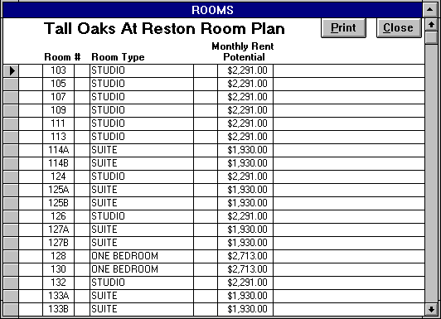

Accounting Database Options

The Accounting Database Options sets some of the general information about the facility required by the database. The information the Administrator enters into this form is reflected throughout the database including any reports or forms it generates. The Accounting Database Options contains the following five fields:

Deposit Account # - enter your facility’s default deposit account #.

Bill Day - enter the default date your facility bills on. This date must either be the 1st or the 26th.

Closeout Date - this date will be automatically entered by the computer when you perform your yearly closeout your accounting records.

First Ancillary - you must select your first noncontractual ancillary service. This list is derived from the Accounting Descriptions form.

Charity Payment Types - in this field you identify each of the payment types for which your facility provides charity. Usually, the charity payment types are limited income and grant.

Press the CLOSE button to exit the form and return to the Admin Menu.

Accounting Descriptions

This form allows the computer coordinator to enter in the income accounts your facility will utilize on the Resident Ledger and through the program. You should enter all the contract services your facility provides followed by your most frequent ancillary services. (Note: Contract services need to be identified in the Lease Fields form in the Market Leap program as billable items.) Rent and Other represent the 1st and 10th ledger accounts respectively, while the 2nd through the 9th accounts are selected by your facility.

Exhibit 65: Accounting Descriptions
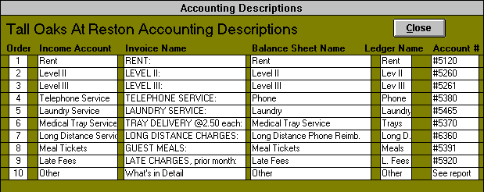

The Accounting Descriptions form also allows the coordinator the flexibility of entering in their own terminology for the income accounts for various forms*. The invoice name field defines how the service will be named on the invoices. The balance sheet field determines the description of the services on most of the rent roll reports. The ledger name field limits the description to 10 characters for those forms with space limitations such as the Resident Ledger and the Resident Rent Roll. The account number must also be entered for each service. Click on the CLOSE button to return to the Admin Menu.

*The other income account cannot be edited.

Account Close-Out

This form allows the computer coordinator to archive old accounting records from the Resident Ledger into the Historical Ledger. The user simply specifies the closeout bill date and clicks on the INITIATE CLOSE-OUT button. All accounting records before the bill date are then stored in the Historical Ledger. A copy of each resident’s ledger prints out and the appropriate balance forward is billed to the individual resident ledgers. When the closeout process is completed, the computer coordinator is returned to the Admin Menu.

Exhibit 66: Account Closeout

See Also
Closing-Out Past Accounting Records

Table of Exhibits
Exhibit 1: Resident Ledger 7
Exhibit 2: Payment Form 8
Exhibit 3: Miscellaneous Collections 9
Exhibit 4: Deposit Ticket 10
Exhibit 5: Confirmed Deposit 11
Exhibit 6: Deposit Balances 12
Exhibit 7: Delinquency Report 13
Exhibit 8: Resident Ledger 15
Exhibit 9: Other Income Options 16
Exhibit 10: Other Income 16
Exhibit 11: Invoice Options 17
Exhibit 12: Invoice Check Report 17
Exhibit 13: Adjustment Form 20
Exhibit 14: Group Reports Print 23
Exhibit 15: A/R Reconciliation Detail 24
Exhibit 16: Accounts Receivable Reconciliation 25
Exhibit 17: Adjustment Report 26
Exhibit 18: Booking By Resident and Unit 26
Exhibit 19: Cash Back Report 27
Exhibit 20: Charity Booking By Unit 28
Exhibit 21: Deposit Balances 29
Exhibit 22: Ledger Check Report 30
Exhibit 23: Other Income Report 31
Exhibit 24: Other Income Detail Report 32
Exhibit 25: Other Income Check Report 33
Exhibit 26: Prepaid Adjustment Check Report 34
Exhibit 27: Prepaid Previous Detail 34
Exhibit 28: Prepaids Report 35
Exhibit 29: Prepaid Reconciliation 36
Exhibit 30: Rent Roll Balance Sheet 37
Exhibit 31: Rent Roll Balance Check 38
Exhibit 32: Resident Billing Comparison 39
Exhibit 33: Resident Rent Roll 39
Exhibit 34: Resident Subsidy Tracking 40
Exhibit 35: Resident Subsidy Amounts 41
Exhibit 36: Resident Subsidy Balances Reports 41
Exhibit 37: Resident Subsidy Ledger 42
Exhibit 38: Security Deposit Balances 43
Exhibit 39: Security Deposit Check 44
Exhibit 40: Security Deposit Ledger 45
Exhibit 41: Services Balance Sheet 46
Exhibit 42: Services Potential Check 47
Exhibit 43: Accounting Period Lock 49
Exhibit 44: Accounting Closeout 50
Exhibit 45: Historical Ledger 50
Exhibit 46: Main Menu 51
Exhibit 47: Change Password 52
Exhibit 48: Accounting Menu 53
Exhibit 49: Resident Ledger 54
Exhibit 50: Miscellaneous Collections 55
Exhibit 51: Balance Sheet Options 56
Exhibit 52: Accounting Check Options 57
Exhibit 53: Deposit Ticket 58
Exhibit 54: Confirmed Deposit 58
Exhibit 55: Invoice Options 59
Exhibit 56: Group Reports Print 60
Exhibit 57: Historical Ledger 61
Exhibit 58: Rent Roll Update 62
Exhibit 59: Accounting Period Lock 63
Exhibit 60: Admin Menu 64
Exhibit 61: Create New User 65
Exhibit 62: Delete User 65
Exhibit 63: Clear Password 65
Exhibit 64: Room Plan 66
Exhibit 65: Accounting Descriptions 67
Exhibit 66: Account Closeout 68

